Creating table and loading the data into table:

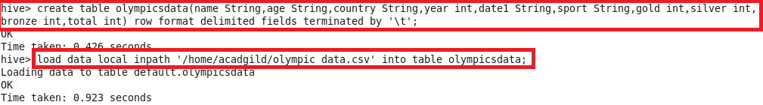

**Problem Statement:**

Write a Hive program to find the number of medals won by each country in swimming.

Write a Hive program to find the number of medals that India won year wise.

Hive Program:

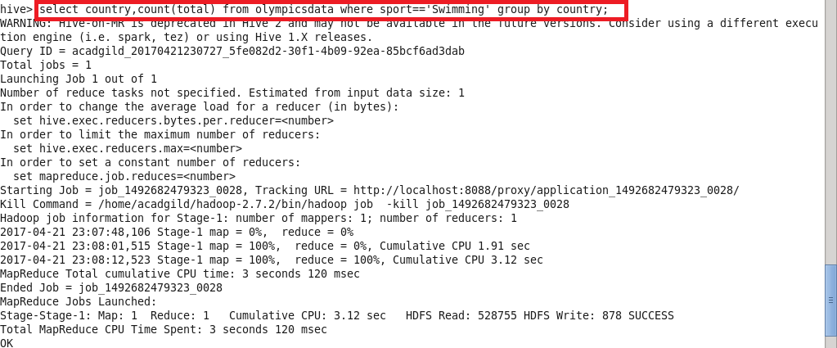

Output:

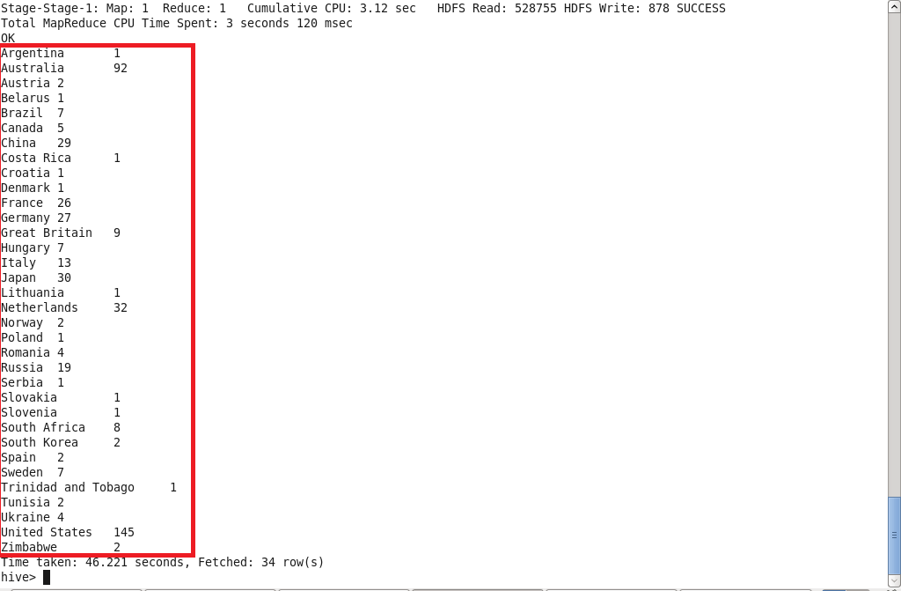

Hive Program & output:

